Derived by assumptions about movement and features:
(7) Motivation for T-to-C movement [in English matrix interrogative clauses]
C bears an uninterpretable T feature (henceforth uT) with the EPP property.

New proposal:

The uT on C is deleted by the nominative wh-phrase. Which is supposed to be the same as this: “Hypothesis (8), which identifies nominative case with uT, is crucial to our explanation of the T-to- C asymmetry. It is this hypothesis that helps us understand why movement of the subject to Spec,CP "does the same job" as T-to-C movement.” (P & T 2001: 6)

Relativized Extreme Functionalism:
“All grammatical features have a semantic value, but recognizes that they do not get a chance to express their semantic value in every context in which they occur.” (Chomsky 1995, Chapter 4; P & T 2001:7)

This allows us to have a grammatical construct like uninterpretable T feature as case and agreement, since those have semantic value. Using this idea we can posit Hypothesis 8.

Hypothesis:
(8) The nature of nominative case
Nominative case is uT on D.

This allows either T to C movement, or wh movement.

(5) T-to-C asymmetry (Koopman 1983)
T-to-C movement, with a non-local wh-moved
a. What did Mary buy?
b. *What Mary bought?
No T-to-C movement, with a local (nominative, capable of checking the uF on C) wh moved.
c. *Who did buy the book? [*unless did is focused]1
d. Who bought the book?

English T has uninterpretable phi features which are realized in some cases with agreement morphology. That’s why nominative case is at T?

C could attract either TP or T since they would both satisfy its feature. However, if it attracted the TP then it would be in effect merging the same constituent twice. This is the situation where head movement happens instead of XP movement.

(12) Closeness
Y is closer to K than X if K c-commands Y and Y c-commands X

Head Movement Constraint of Travis (1984).
Travis's condition states that head movement is always movement from a complement to the nearest head.

(13) Head Movement Generalization
Suppose a head H attracts a feature of XP as part of a movement operation.
(i) If XP is the complement of H, copy the head of XP into the local domain of H.
(ii) Otherwise, copy XP into the local domain of H.

Structure for 5a, 5b. C° has to satisfy its two features in two movements since the wh-element doesn’t have the nominative case that would satisfy uT.
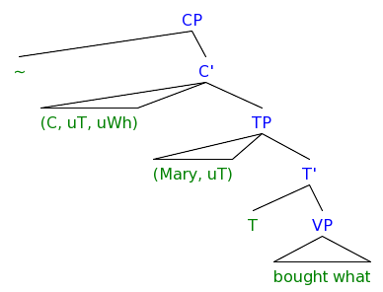
[CP ~ [C' (C, uT, uWh) [TP (who, uT) [T' T [VP bought the book ] ] ] ]]

The more economical choice is to only attract the nominative wh element. This derives (5d).
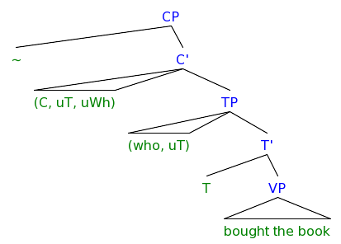

Since Hypothesis (8) is important to the analysis lets look more about it.

“Hyotheses like [uT on D is nominative and uT on T is person/number agreement] bear on central issues of linguistics.”(P & T 2001:8)

I agree, why does the grammar have uninterpretable features at all? Because of the way that percolation works. Percolation doesn’t just project the equivalent of category features, it also projects agreement features that allow language users to overtly mark things that go together. Why would it do this? Functionally we can see how overt markers evolve. Why overt agreement evolves may be due to reduced pronouns, what about multiple gender agreement?

If T assigns nominative to its spec, then we expect different types of T (present, past, future) to effect the case on the spec of T. This is not commonly found but maybe Pittapitta (Hale1998) shows something of import. Future tense is marked on the subject, but no other tense is marked on the subject.

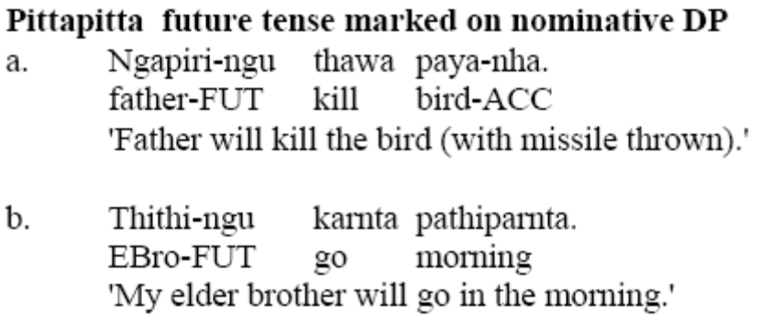

In classical Arabic the suffixes for nominative are identical to the mood marker of the imperfect indicative verb. (Benmamoun 1992)

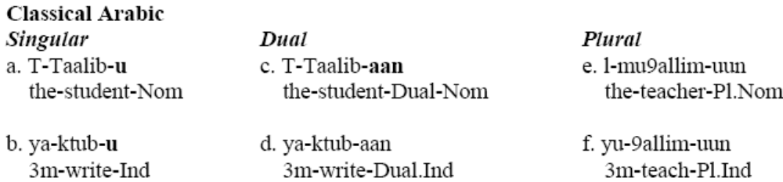

Pesetsky and Torrego 2001 suggest that accusative might be the uninterpretable features of v or Borer’s 1998 aspect.

… some discussion of multiple wh movement, which helps us tie the T-to-C movement with wh-movement, notice that both happen in the English sentences…

(22) Attract Closest X (ACX)
If a head K attracts X, no constituent Y is closer to K than X.
Arguments for ACX:
The that trace effect

The that trace effect:
a. Who did John say __ will buy the book?
b. *Who did John say that __ will buy the book?

What if that isn’t C, but a T that has moved to C. Compare this to the auxiliary (would, did) in Belfast English. It would have to be leaving something similar to a resumptive pronoun.

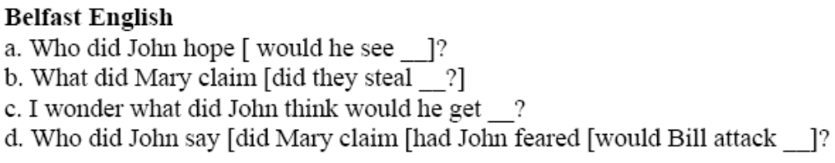

The derivation of the that trace. In the embedded clause the most economical movement is one that will satisfy both uWh and uT, that’s a movement of “who,” this blocks the less economical movement, that of T to C, and so the “that” cant be said, since its never there.

My question is, apart from the fact that we have T to C movement in interrogatives, why does it make sense for C to have a uT feature anyway??

4. Movement of the nominative subject to Spec,CP in embedded declarative clauses

We should view English that as T-in-C in all clauses,

The C of embedded declaritve clauses has a uT feature which, when “that” is missing, is satisfied by the embedded subject

(33) Mary thinks Sue will buy the book.
cf Mary thinks that Sue will buy the book.

Both with and without “that” is possible because the uT on C can be satisfied equally economically by moving T (you get the “that”) or TP (you get no “that”).

If the TP is moved when there is no that, shouldn’t we get an island for extraction?

So, C always has uT features. This makes sense with some of Rizzi’s discussion of agreeing complementizers.

5. T-to-C movement vs. subject movement in matrix questions

Can we just move the embedded subject, even if its not a wh, to satisfy the uT on C?

Exclamative vs. interrogative interpretation
A matrix CP whose head bears uWh is interpreted as an exclamative if a non-wh-phrase appears as one of its specifiers. Otherwise, it is interpreted as a question

If a non-wh is in the spec of an embedded CP then it’s a Exclamative, if there is T-to-C movement, its not an Exclamative.

